Stage 1 - Programming Language - Java

Stage 2 - Selenium (Web Application) & AutoIT (Windows automation)

Stage 3 - Hybrid Framework

Stage 4 - CI/CD - Git and Jenkins

Selenium - <https://www.selenium.dev/>

* Open Source
* Language independent - Java, C#, Python, Ruby, Javascript, php, perl

Selenium - A suite of tools

1. Selenium IDE
   1. No need programming language
   2. Record and playback feature
   3. Supports - Chrome, Firefox, Edge
   4. Simple scripting or exploratory testing
2. Selenium RC - Depreciated
   1. Programming language is must
   2. Java, C#, Python, Ruby, Javascript, php, perl
   3. Architecture

Source code (Java+Selenium RC) 🡪 RC Server (Turn on/off) 🡪 Browser

1. Selenium WebDriver
   1. Programming language is must
   2. Java, C#, Python, Ruby, Javascript, php, perl
   3. Architecture

Source code (Java+Selenium WebDriver) 🡪 Browser

1. Selenium Grid
   1. Hub and Node

Java Programming -

1. Installation
   1. **JDK 8 (Java Development Kit)** 
      1. By default - it will install JRE (Java Runtime Environment)
   2. IDE
      1. Eclipse
         * https://www.eclipse.org/downloads/packages/
      2. IntelIJ
      3. Netbean
   3. Browser

<https://ftp.mozilla.org/pub/firefox/releases/94.0.2/win64/en-US/>

1. Architecture

Source code (.java) 🡪 Byte code (.class) 🡪 O/P

Compile time vs Runtime

Compile time - Source code (.java) 🡪 Byte code (.class)

Runtime 🡪 Byte code (.class) 🡪 O/P

1. UpperCamelCase - MyFirstProject

lowerCamelCase - myFirstProject

1. Eclipse Structure

Workspace (lowercase)

Project 1 (UpperCamelCase)

Package 1 - lowercase (com.vfislk.purpose or org.vfislk.purpose)

Class (UpperCamelCase)

Methods & variable (lowerCamelCase)

Package 2

Project 2

1. Datatypes
   1. Primitive datatypes / Pre-defined
      1. Byte - 8 bit

7 bit for storing the number

1 bit for sign + or -

* 1. Non-Primitive datatypes / non-predefined - collection of primitive datatypes
     1. String
        + Zero based index
     2. Array
        + Zero based index
        + Size is fixed

1. Exception in thread "main" java.lang.ArrayIndexOutOfBoundsException: 5

at com.vfislk.datatypes.DatatypesDemo2.main(DatatypesDemo2.java:17)

1. Relational operators -

==, !=, >,<,>=,<=

1. Logical operators - And (&&), or (II) not
2. Debugging
   1. Breakpoint
   2. Resume
   3. Terminate
   4. Step over
   5. Step into
3. Conditional statements
   1. If , if else, if else if
   2. Switch
4. Iterative statement
   1. For
      1. Start point
      2. End point
      3. Iteration
   2. For each/ advance for loop - designed for handling array and collections
   3. While
   4. Do while - minimum once it will run the code
5. Access modifier
   1. Private - accessible within the class
   2. Default - accessible within the package
   3. Protected - accessible within the package and also with inheritance
   4. Public - anywhere
6. Methods - Building block of the program
   1. Reusability
   2. Maintenance

* Static Methods
  + Create and Call it
  + To call the static method

Classname.methodname()

//accessmodifier static returntype methodname(arguments)

* Non-Static Methods
  + Create and Call it
  + To call the non-static method
    - Create object for that class
    - Use objectref.methodname()

1. Object
   1. Declaration (Area obj)
   2. Instantiation - new (allocate memory)
   3. Initialization (Area())
2. Variable
   1. Static variable
   2. Non-static variable
3. Class & Object
   1. Real time example
4. Encapsulation
   1. Process of hiding the internal members.
5. this keyword - helps to distinguish between instance variable and local variable.
6. Constructor - Anything pre-requisite for the object
   1. Constructor name and class name should be same
   2. When no constructor created then there will be default constructor which will initialize all the non-static variable
   3. Can create constructor with parameter or without parameter
   4. When constructor is created explicitly then you need to call that constructor on creating object
7. Import option:
8. Constructor overloading

We can create multiple constructor inside the class

By change

1. Number of parameters
2. Datatypes of parameters
3. Sequence of parameters

The constructor to be called is resolved during compile time.

1. Method overloading/ Compile time polymorphism/ early binding

We can create multiple method using same name inside the class

By change

1. Number of parameters
2. Datatypes of parameters
3. Sequence of parameters

The method to be called is resolved during compile time.

1. Inheritance
   1. Reuse the methods
2. Method overriding/ Run time polymorphism/ late binding
   1. Recreate the method in child class with different definition.
   2. Object of the child class should be stored in parent.
   3. Based on object created if the method is overridden then that method will be called.
   4. The method to be called is resolved runtime.
3. Abstract class - set of the rules to be followed by child class
   1. If no definition known then we can make the method as abstract.
   2. If any of the method is abstract, you need to make class the abstract.
   3. Cannot instantiate the abstract class
4. Interface - - set of the rules to be followed by child class
   1. Contains only method declaration
   2. All methods are by default public and abstract
   3. Cannot instantiate the interface

______

* Achieve cross browser testing (code should be present in all browser class)
* Lower level module should depends on higher level module

Selenium WebDriver

1. Create a java project
2. Download and configure the selenium jar (4.1.0)
   1. Download <https://www.selenium.dev/downloads/>
   2. Right click on project 🡪 Build Path🡪 Configure Build path🡪 Libraries 🡪 Choose classpath🡪 add external jar
3. Exception in thread "main" java.lang.IllegalStateException: The path to the driver executable The path to the driver executable must be set by the webdriver.chrome.driver system property;
4. To fix above error:

Download and configure the driver based on the browser and browser version.

<https://chromedriver.chromium.org/downloads>

Use anyone option:

* Keep it project home directory
* Using System.setProperty
* Using webdrivermanager (automatically download and driver)

1. Internet Explorer
   1. Zoom level - 100 %
   2. Security mode should be same either disable or enable (check img 1.3 )
2. Selenium doc - <https://www.selenium.dev/selenium/docs/api/java/org/openqa/selenium/WebDriver.html>
3. Click, Sendkeys, Select

Notes:

1 bit - 0 or 1

1B - 8 bit

1KB - 1024B

1 MB - 1024KB

1 GB - 1024 MB

Ref

Img 1.0

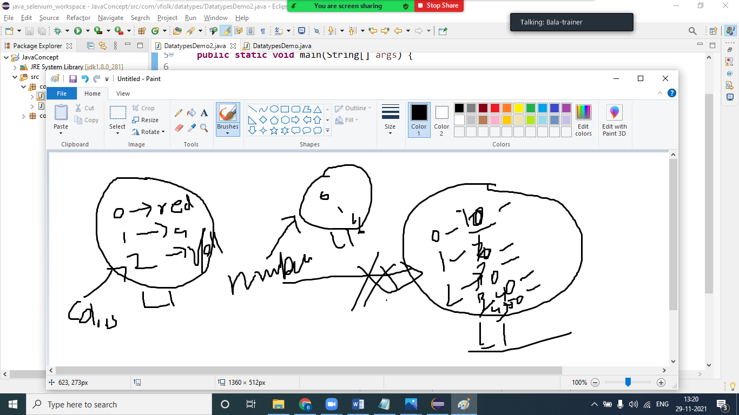

Img 1.2

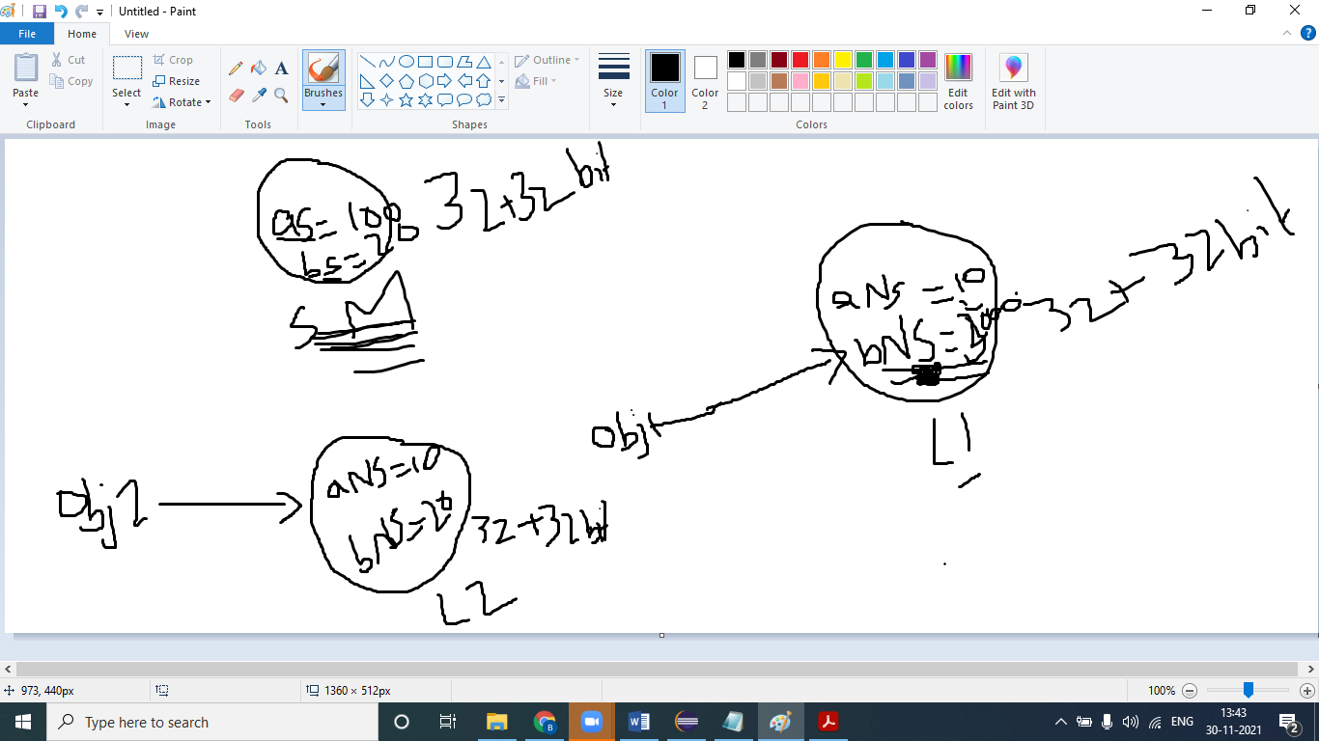

Img 1.3

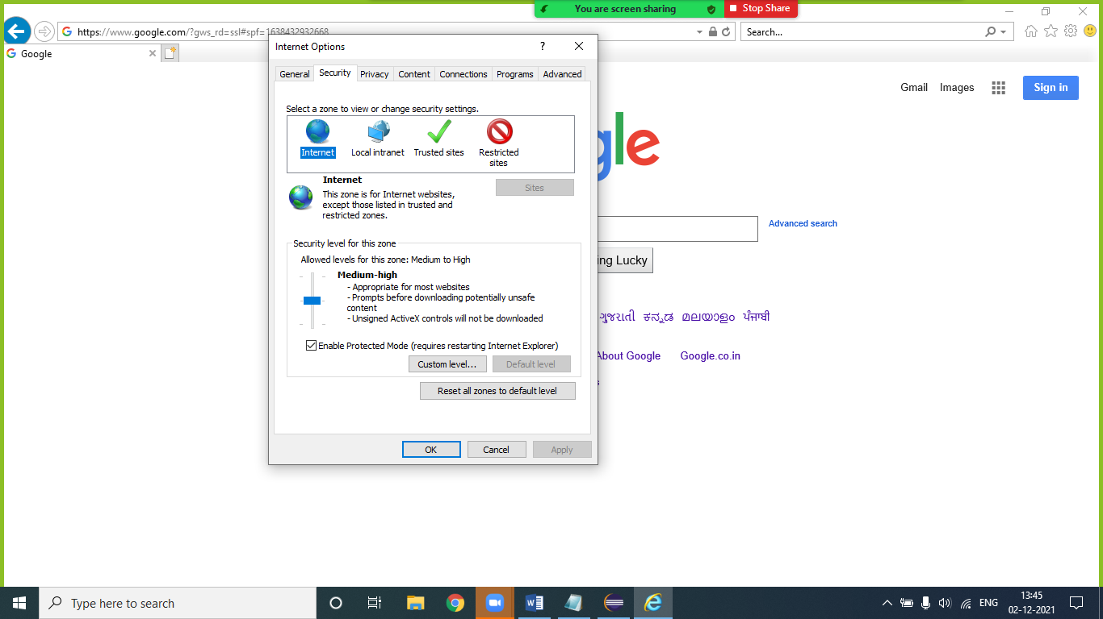

https://github.com/balaji-githubstore/VFISLK3.git

Task

|  |  |
| --- | --- |
| **PERCENTAGE** | **GRADE** |
| 90 and above | A |
| 80 to 89 | B |
| 60 to 79 | C |
| 45 to 59 | D |
| below 45 | F |

Task2:

1. Create Student type with below details (decide between static and non-static variable)

**Student**

* **studentRollno (public)**
* **studentName (public)**
* **studentMailid (public)**
* **studentPercentage (public)**
* **schoolName (public)**

1. **Create 3 different instance for storing below values**

**1001,"jack",jack@gmail.com,45.2, Global school**

**1002,"peter",peter@gmail.com,85.2, Global school**

**1003,"mark",mark@gmail.com,56.5, Global school**

1. Create a method for printing Student details

// public static void printEmployeeDetails(Employee emp)

// {

// System.out.println(emp.empId);

// System.out.println(emp.empName);

// System.out.println(emp.empSalary);

// System.out.println(Employee.companyName);

// System.out.println("*******************************");

// }

// Employee.printEmployeeDetails(emp1);

// Employee.printEmployeeDetails(emp2);

// Employee.printEmployeeDetails(emp3);